Solo Exhibitions: Richard Long
1985: Milan - Padiglione d'Arte Contemporanea di Milano
1986: New York - Solomon R. Guggenheim Museum
1987: Athens - Jean Bernier
1988: Düsseldorf - Konrad Fischer
1989: Halifax - The Henry Moore Sculpture Trust Studio
1990: London - Anthony d'Offay Gallery
1991: Liverpool - Tate Gallery
1992: Barcelona - Fundació Espai Poblenou
1993: Santa Fe - Center for Contemporary Arts
1994: Sydney - Museum of Contemporary Art
1995: Reykjavik - Onnur Hæd Sýningarsalur
1996: Tokyo - Setagaya Art Museum
1997: Bristol - Bristol City Museum & Art Gallery
1998: Wakefield - Yorkshire Sculpture Park
1999: Athens - Bernier/Eliades
2000: Bilbao - Guggenheim Bilbao
2001: Paris - Galerie Daniel Templon
2002: Venice - Griffin Contemporary
2003: London - Haunch of Venison
2004: Seoul - Kukje Gallery
2005: Glarus - Galerie Tschudi
2006: San Francisco - Museum of Modern Art
2007: Edinburgh - Scottish National Gallery of Modern Art

Chelsea Ball
&
Ilyse Lax

Richard Long

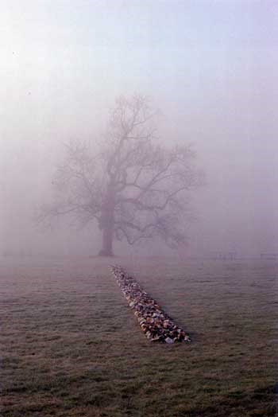
Tame Buzzard Line
New Art Centre Roche Court England, 2001

Richard Long. Artist.
Art made by walking in landscapes.
Photographs of sculptures made along the way.
Walks made into textworks.
1945: Born in Bristol, England.
1962-5: Studied at West of England College of Art, Bristol.
1966-8: Studied at St. Martin's School of Art, London.
“In the mid-sixties the language and ambition of art was due for a renewal. I felt art had barely recognized the natural landscapes which cover this planet, or had used the experiences those places could offer. Starting on my own doorstep and later spreading, part of my work since has been to try and engage this potential.” ~R. Long
Nature has always been recorded by artists, from pre-historic cave paintings to modern day landscape photography. Long too would record nature through the act of walking. Walking has a long cultural history, from Pilgrims to the wandering Japanese poets or English Romantics. Long uses walking in new ways to create his sculptures. His first work was made by walking in 1967. It was a straight line made in a grass field, on a path going 'nowhere'. Each subsequent walk would follow a unique, formal route, for an original reason other than travelling.
Each walk would realise a particular idea – an idea made real through the act of walking. Long does not offer what any idea might be but he does show the relationship between geography, mapping, time and distance for each completed walk. Once a walk has been completed Long presents each in one of three ways: in maps, photographs or text works, using whichever form is the most appropriate. All these forms feed the imagination, so that the viewer might experience the ‘real’.
“My work is real, not illusory or conceptual. It is about real time, real stones, real walks. I use this world as I find it.” ~R. Long
Walking has enabled Long to extend the boundaries of sculpture; to be de-constructed in the space and time of walking. A stone carried on a walk can be a marker of time/distance, or exist as parts of a larger sculpture. It is as much about place as it is about material and form. Yet there is still something about walking that disrupts what a sculpture can be. Our visual culture is accustomed to art being made of any material what so ever as long as there is a physical form or attributes that can be perceived.
While Long is known for his walking pieces, he also makes ‘sculptures’ for gallery spaces. These works will follow in his use of nature for subject and material but make a significant shift to how he references nature. By using locale materials (stone, wood, mud) circles and lines are sculpted. These are shapes owned by all people across history and natural to us all.
Sculptures and Mud Paintings
By: Chelsea Ball & Ilyse Lax
There are several aspects to the work Long creates for a gallery. His sculptures created without a walk offer more permanence which is of concern. Many earth artists work with nature in a non disruptive manner – all processes can be reversed through acts of nature: wind, gravity, weathering. Long’s walks consist of treading a path, moving the dirt or carrying a stone along his walks. However, when creating a sculpture that is removed from nature, Long ensures that the experience is present.
To understand this experience, we have acted in a similar manner to recreate a scaled version of a few of Long’s sculptures. Circular sculptures have been crafted out of local available material and used in a manner that best suits it. We have taken the time to play with the composition, physically working with nature as Long would have. To further understand how Long wants the world to re-immerse itself in nature, we have recreated several of his famous mud paintings. Long uses mud in the form of paint to record his impact on nature. Using his bare hands mud is applied to surfaces as if paint. The interaction of these two materials along with the natural process of gravity gives life to each material. One can see nature’s representation in the splatters and imperfections the mud leaves behind in each panel.
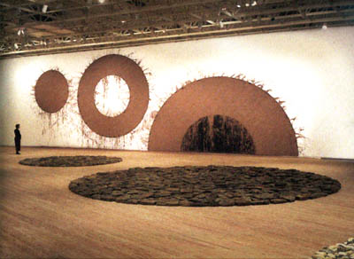From One to Another
Houston Texas, 1996

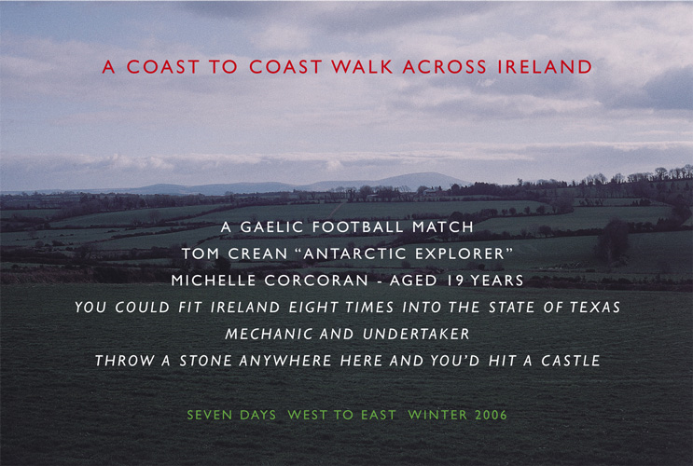 A Coast to Coast Walk Across Ireland
Ireland, 2006
Our experience of nature as per Long was only half completed with re-creating his sculptures. Longs walks are done in solitaire and the specifics left unknown to the public. To further interpret Long’s use of nature we have composed our own walk and will document the experience as we see fit. Instead of using Long’s standard line or circle, the shape of a spiral has been chosen for its natural occurrence and predominating shape used by other earth artists.
From a predetermined starting point we will walk along the roads in London Ontario that intersect to form a spiral. The length of the spiral and set intervals will be pre determined before the walk but not disclosed to the viewer. At each determined interval a photo will be taken to record the experience of nature as best as possible. We will present our audience with a photo, including text such as Long does that intrigues the viewer and gives a sense of what might have occurred. This sense of wonder will ideally be used to provoke the audience to experience nature as we have. The text will be minimal and selected only after the walk has been completed.
What is important to note here is that much of the work will be determined only after the experience of the walk. The experience is vital to any photo, text or representation of nature. By leaving out specifics such as distance and time, we have deviated from Long’s working methodology. We have also felt that to exclude this information forces wonder upon the viewer, wonder of the experience of nature that we pass by everyday without notice.

