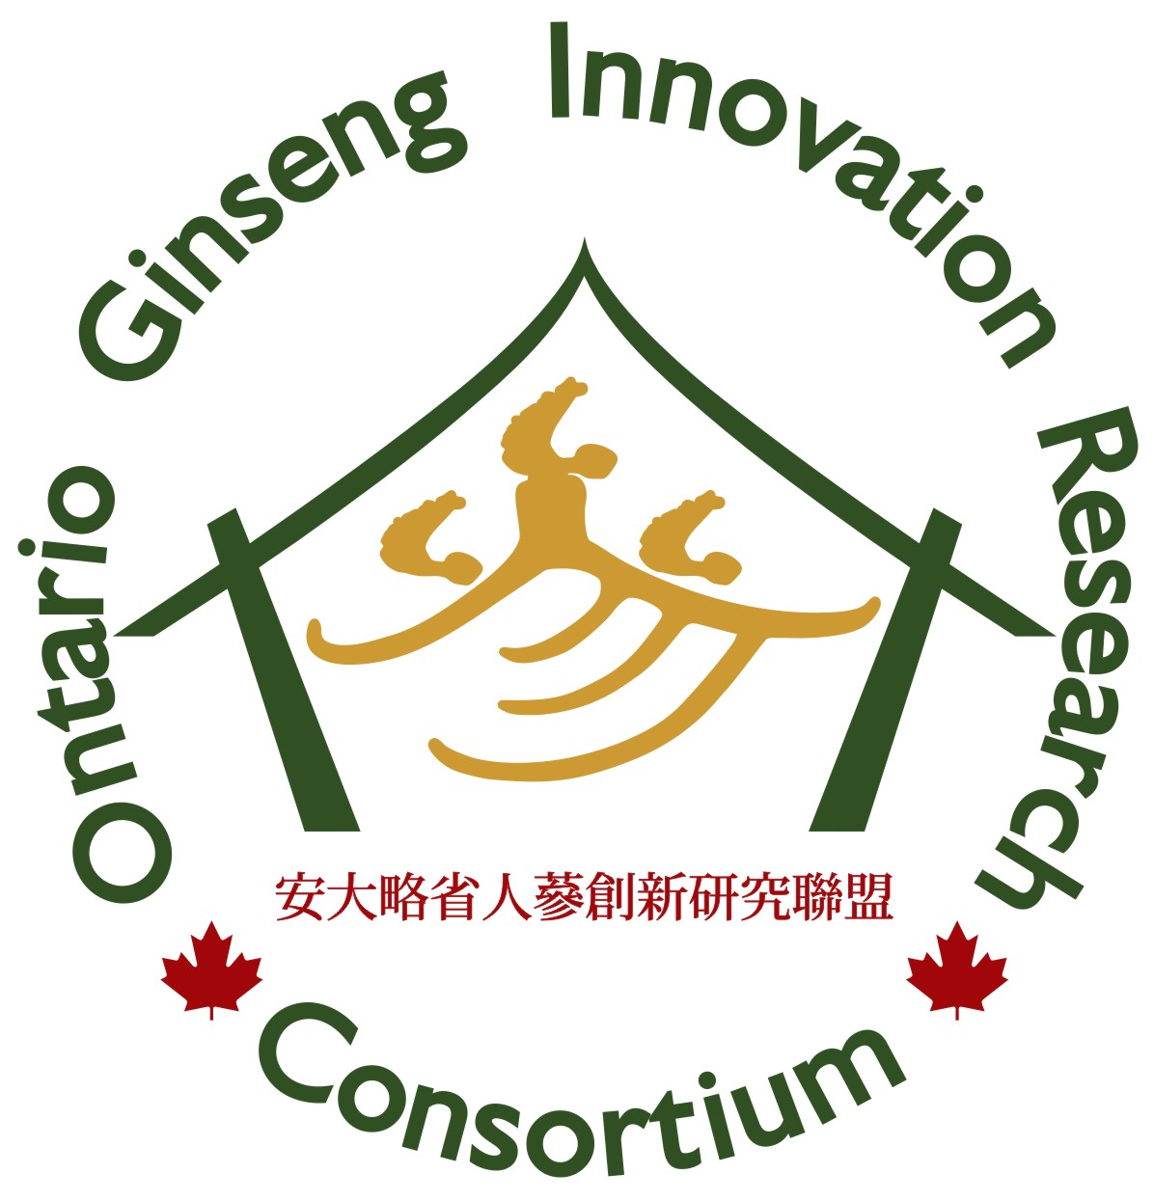 | Ontario Ginseng Innovation and Research Consortium  Department of Physiology and Pharmacology  Schulich School of Medicine and Dentistry  The University of Western Ontario  London, Ontario Canada N6A 5C1 | 

