Cultures of Italy
Italian 3330G
Winter 2027
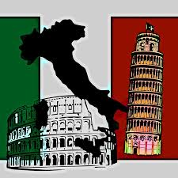
What makes “all things Italian” so widely appealing, and why is the boot-shaped peninsula one of the world's most popular tourist destinations? These questions provide the starting point for Italian 3330, a course that explores the extraordinary cultural richness of Italy's past and present. Together, we will examine the many expressions of the so-called "Italian genius," from visual arts and literature to music, and consider how these cultural achievements have shaped Italy's enduring global influence and appeal. (Course structure: 3 hours per week; Instructor TBA).

Prerequisite(s): Italian 2200 (or Italian 2202X) or permission of the Department.
Learning outcomes
Upon successful completion of this course you are expected to be able to:
- understand a number of key aspects of Italian culture in a historical perspective
- research autonomously a variety of topics related to the culture and history of the Italian people
- communicate in spoken and written Italian with enhanced proficiency
- engage with a broad array of text types
Evaluation (subject to change) = Quiz (20%), Midterm (25%), Oral Presentations (15%), Participation (10%), Final Exam (30%)

