DEPARTMENT OF LANGUAGES, CULTURES AND LINGUISTICS
WESTERN UNIVERSITY Fall 2026

CLC 2141A FOOD AND HEALTH IN THE MIDDLE AGES

This course outline is provisional and subject to change.

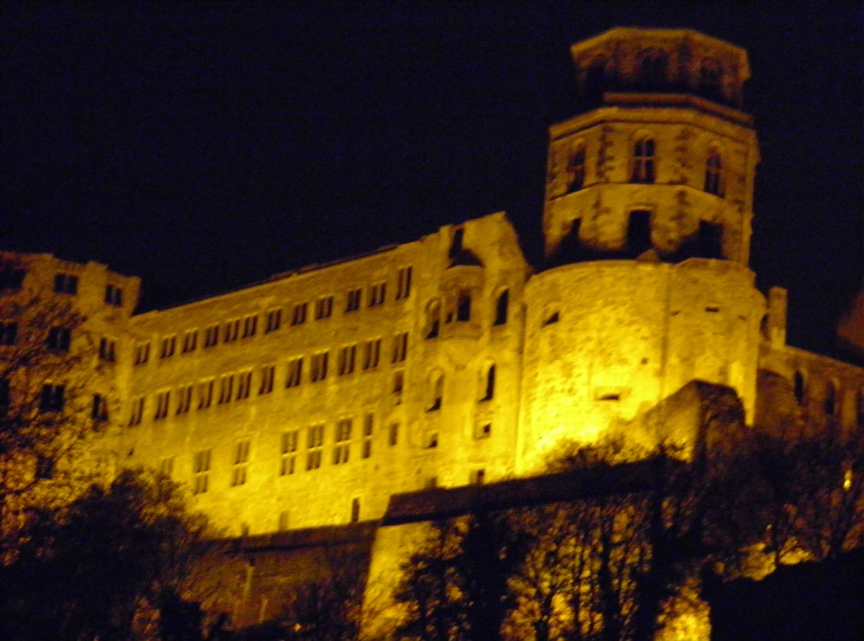

COURSE CONTENT
Discover the fascinating world of medieval food culture and explore the role nutrition played in
the theory of health and wellness. Study the presumed medicinal properties of the foodstuffs
available in pre-Columbian Europe, their preparation and consumption, and try your hands on
period recipes from the different regions.

AIMS
- develop an understanding of food’s central importance in medieval society
- study the close connection between food, identity, and health
- find out what foods were available in medieval Europe before the discovery of the New World
- explore the role ancient and medieval medicine played in food selection, preparation, and
gastronomy

OUTCOMES
Upon successful completion of the course students will have
- acquired the tools to conduct research in medieval food culture, and the theory of nutrition
- gained an understanding of the historical, social, economic, regional, religious and medical
influences on medieval food choices and eating habits
- been introduced to and have applied an interdisciplinary approach to medieval food culture
spanning the Humanities, Social and Health Sciences

ASSESSMENTS FOR CLC 2141 (TENTATIVE)
Project 40%
Midterm 25%
2 Short Essays (500 words each) 20%
Participation 15%

COURSE MATERIAL
Adamson, Melitta. Food in Medieval Times (Westport, CT, and London: Greenwood Press, 2004)

