This is for the course that we are still waiting for the code (Spanish, Asian and Canadian Culture).

Spanish 2120 Language and Society in Hispanic, Canadian, and Asian Cultures. Winter 2023

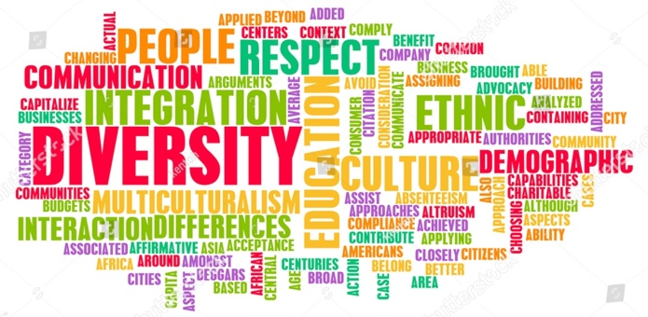
Course Description This course is an introduction to the study of the relationship between language and society with the goal of understanding social structure through language. In this course, we specifically focus on three main cultures: Canadian, Hispanic and Asian. We compare their differences by working within socially-informed perspective; topics covered will include language, perception, and identity development; verbal and non-verbal communication; speaking across cultures; language use and social networks; and language and power.

No pre-requisites, open to all. Course is taught in English.
*For Spanish students, final project should be submitted in Spanish

- Course Goals and Objectives
This course aims to achieve the following:
- Introduce concepts necessary to understand the role of language in society
- Define key terms used by linguists carrying out research in this area
- Connect theoretical concepts to everyday experiences
- Understand differences according to cultural norms

- Learning Outcomes
Upon completion of the course, students will:
- Become familiar with the main terms and concepts while studying language and society
- Will be able to apply the concepts studied during the semester while critically assessing different population groups
- Become aware of similarities and differences among Canadian, Asian and Spanish cultures
- Get knowledge of an observational linguistic method while studying different groups
- Learn how to write a solid linguistic proposal and paper

- Evaluation
Below is the evaluation breakdown for the course. Any deviations will be communicated.
Assessment | Weighting
Online quizzes (5% x 5) | 25%
Online forum discussion/debate | 20%
Participation | 10%
Independent group project | 10% proposal  10% oral presentation  25% essay

