SP3319A/LIN2244A “SECOND LANGUAGE ACQUISITION. ACQUISITION OF SPANISH” FALL 2022

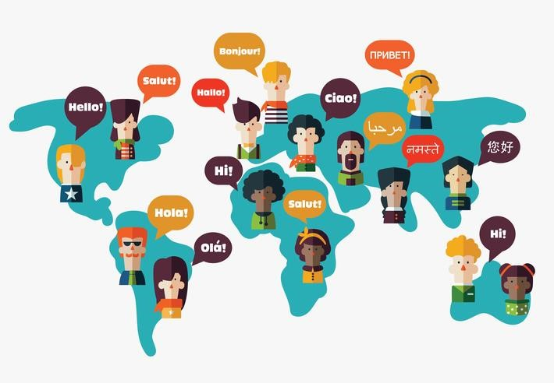

Course Description and Design
Requisites for SPA students: Pre-or Corequisite(s): Spanish 2200 or Spanish 3301E or permission of the Department.
Prerequisite(s) for LING students: One of Anthropology 1027A/B, Linguistics 2288A/B, Spanish 3303A/B, or both French 2805A/B and French 2806A/B or permission of the program.
This course will be an introduction to research on language acquisition with a specific focus on Spanish as the second language. Using a core textbook and recent articles, students will learn about different theories regarding acquisition, the role of individual differences, as well as the main characteristics of learner language. Students will be able to connect this body of knowledge to their own learning and as a result, to carry an experimental work or analyse a corpus work as part of the group project. The course is taught in English. If you are a student who is taking this course part of the Spanish minor/major requirement (SP3319A), the final project will be submitted in Spanish.
All course material will be posted to OWL: http://owl.uwo.ca. Any changes will be indicated on the OWL site and discussed with the class.
If students need assistance, they can seek support on the OWL Help page. Alternatively, they can contact the Western Technology Services Helpdesk. They can be contacted by phone at 519-661-3800 or ext. 83800.

Course Goals and Objectives
This course aims to achieve the following:
Introduce students to first and second language acquisition and factors that are involved in acquiring a language
Present various debates and theories on SLA
Learn how to analyse data and write a linguistic essay

6. Learning Outcomes

Upon successful completion of this course, students will be able to:
Understand how children and adults acquire a language

Understand the relationship between major theories of SLA and the process of acquiring a second language
Extract & analyse data
Write a solid linguistic essay

7. Resources
All lectures will be posted in OWL. (List of course readings and course calendar included in the last pages of this document)
Required textbook: Lightbown, P. & N. Spada. (2021) How Languages are Learned
(FifthEdition). Oxford University Press. https://bookstore.uwo.ca/textbook-search?campus=UWO&term=W2021A&courses%5B0%5D=001_UW/SPA3319A

8. Evaluation
Below is the evaluation breakdown for the course. Any deviations will be communicated.
Assessment | Format | Weighting
Midterm | In-Person | 20%
Oral presentation (on any of the assigned articles) | In-Person, during tutorials | 10%
Participation & Preparation | - In class  - In OWL discussion forums | 10%
TCPS2 Tutorial | (3 hours) | 5%
Group Project |  | 15% Project outline  15% Oral presentation  25% Essay

Midterm (20%)
Midterm will occur during Tuesday class (online, timed) on October 26, and will include the material of Chapters 1-3, as well as the articles discussed during the tutorials. The format will be mixed (multiple choice, true & fall, as well as short answers).

Oral presentations (15%)
A student each week will prepare a presentation on one of the articles from the reading list (see the dates and the article list below). Presentations will be no more than 20-25 minutes and include a summary of the article, critical analysis of the article, as well as two short activities at the end to promote the audience’s interaction with the material that has been presented. Think of engaging and creative activities.

Participation, Preparation and Engagement (10%)
Students are expected to participate and engage with content as much as possible.
Students should also participate in tutorials by interacting during presentations with their peers and instructors

Students are expected to attend all the classes (lecture and tutorials). Inconsistent attendance (including frequent absences and late arrivals) will negatively impact your level of participation and will significantly affect your final participation grade. Attendance without active participation will lead to a poor final participation grade. Since this course is fully online, participation will be measured in two ways: 1) 5% active participation in lectures and tutorials, 2) 5% active participation during discussion forums (e.g., by writing in full sentences, critically assessing the discussion questions, answering your peer’s questions). To ensure, your participation is taken during class, it is recommended you have cameras on all the time.

Group project (55%)
During the semester, students will work in groups of 4 and have an option of either analysing a corpus work with a focus on L2 acquisition or carrying an independent work.
- Final project proposal (15%): a 5-page proposal including the references (minimum 5 sources) will involve submitting your project including the description of the phenomenon, main research question(s) and hypotheses; (some of) the previous research on the topic; a brief outline of possible methodology including the participants and stimuli
  - Note for Spanish majoring/minoring students: your proposal has to be submitted in Spanish and focus on Spanish acquisition
  - Final project presentation (10%): During the week 12, you will present your course project/term paper (PowerPoint presentation) for a duration of 15-20 min. Your presentation must include a description of the phenomenon under study, your research questions, hypotheses, previous research on the topic, methodology, data analysis and results, discussion, conclusions and future work.
  - Final essay (25%): The final paper is a written version of your PowerPoint presentation. The paper must contain a description of the phenomenon under study, your research questions, hypotheses, previous literature, methodology, data analysis, results, discussion, conclusions and future work. The paper should not exceed 15 pages (Times New Roman, 12 pts, 2 spaces). A hard copy of the papers together with an electronic copy must be submitted to the instructor by email. The term paper must be submitted on time.
  - Note for Spanish majoring/minoring students: your proposal has to be submitted in Spanish and focus on Spanish acquisition

TCPS2 tutorial (duration 3 hours; 5%)
As part of this course, each student (whether they pick to conduct an experimental project via Google doc survey or use a corpus) requires completing an online tutorial/course. The purpose of this online course is to provide an introduction to research ethics principles and applications for researchers. A number of examples, media reports, and external links are included to illustrate the impact of research design decisions on participants, researchers, and society as a whole. Upon completion, students will receive a certificate that must be forwarded to the instructor in order to receive 5%. Those students who will be doing an experimental work must complete TCPS2 PRIOR to carrying experimental work.
ETHICS: Because the final project involves research using human subjects, the student will read the Tri-
Council Policy Statement, as well as the relevant information on the office of research ethics website at Western (http://www.uwo.ca/research/ethics/). The student will not collect any data until ethics approval has been obtained. Besides, one representative of the REB office will come to class to give a workshop on research ethics. All students must complete the TCPS2 tutorial (http://tcps2core.ca/welcome).
Final project (for those students who will conduct an experimental work only):
The goal of this project is to introduce the student to empirical research on language acquisition. The student will choose a linguistic topic of their interest and choose the most appropriate method according to the proposed research question to run her own pilot project. The student and the professor will together discuss the ethical issues surrounding this project. The student understands that participants must be recruited in a way that does not threaten their privacy. Potential participants will be given a letter of information and a consent form and informed of their right to refuse to participate and to withdraw at any time. They will also be given contact information if they are interested in seeing the final project. All data collected will be encoded to protect participants’ confidentiality (e.g. names replaced by numbers). The student understands that the project must not involve more than minimal risk to the participants, as set out in the guidelines posted on the research ethics website.
Participants (older than 18+) will be recruited from among acquaintances and/or other students from their department (e.g., undergraduate students from SP3300, Italian students or French students). The audiorecordings will be coded.
The data will be collected by means of on-line questionnaires, paper and pencil short tasks, or by audiorecording the participants, according to the most appropriate methodology for the topic under investigation. The researcher will explain in detail the nature of the project together with all necessary information: terms of the withdrawal, confidentiality and privacy, duration of the tasks to the interested participants. The terms of withdrawal will be written in the consent form and will be read and signed prior to testing. However, if at any point, participants feel uncomfortable or unwilling to proceed, they will withdraw at any time. The data of those participants who decide to withdraw will not be used for the current project and will be recycled as soon as participants leave the project. Interested participants will be given a contact information of the instructor and the student whom they will be able to contact to see the results of the final project. There will be no anticipated risks or discomforts associated with participating in the study.
The data will be handled, coded and/or transcribed by the student, who will also analyze it to write the final project report. All data (tapes, spreadsheets created by the on-line survey, paper tasks, messages, etc.) will be destroyed after the grade appeal date for Dec 2022 (the mentor will ensure that the data are in fact destroyed). As stated in the syllabus, all testing materials must be justified according to the topic studied and will be carefully reviewed by the professor for approval prior to beginning her study. The students will prepare a letter (LOC) that contains the details of their project and submit it to her mentor for approval prior to beginning their study.

