Opportunities for Study and Travel
in Germany and Austria

- What is Study Abroad?
1. Students pay fees levied by host university overseas.
2. Students require a Letter of Permission (LOP) from their Faculty, found at
http://www.registrar.uwo.ca/course_enrollment/letter_of_permission.html
3. Please take the LOP to the undergraduate chair of Languages and Cultures – Cristina Caracchini
4. You may choose which university you would like to attend. Some locations are suggested below.
5. Students receive numerical or alpha grades for no more than 5.0 credits.

- What is an Exchange?
1. Students pay regular Western Fees
2. Students can apply for Western International scholarships, found at
http://www.uwo.ca/international/learning/go_abroad/funding.html
•Some scholarships include: The Ontario International Education Opportunity Scholarship, “Go Global” Arts and Humanities, German Exchange Travelling Fellowship, Sunlight Foundation International Exchange Award, Diana Beattie Exchange Scholarship etc.
3. Students apply through the Western International – apply early! Application deadlines vary. Check with Exchange Office.
4. Courses are marked as pass/fail or pass with distinction on the academic record.
5. Students may take no more than 5.0 credits.
6. Please fill out a letter of permission (LOP) and take it to the undergraduate chair of Languages and Cultures - Cristina Caracchini

Please Note: A language course equivalent to 1.0 UWO must have at least 80 contact hours, and be similar in content to a UWO course. For further information, contact the undergraduate chair of Languages and Cultures - Cristina Caracchini

I. Summer Study Programs (with scholarships opportunities)

- OBW INTERNATIONAL LAKE CONSTANCE SUMMER SCHOOL
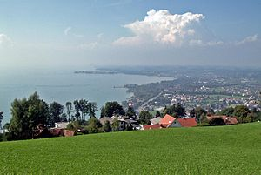
A summer program that allows you to take classes on both German language and the culture of the surrounding German-speaking countries. Language classes are offered at various levels, including beginners, so there is no need for former knowledge of the German language to apply. The program includes class time as well as educational excursions.
Eligibility: must be a permanent resident or citizen of Canada, who has completed at least one year of study
at UWO, and who will be continuing studies at Western after the program. A Letter of Permission from your Faculty is also required.
OWB Link
Duration: 4 weeks (August)
Deadline: Early 2024 (apply to Western International)
Contact person link

- SUMMER PROGRAM AT THE UNIVERSITY OF VIENNA
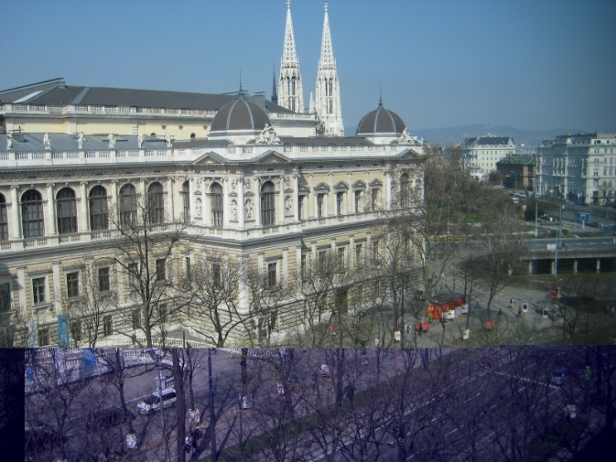
The International Summer Program offers academic lectures about Europe ("European Studies") from different fields, including Law, Political Science, Economics, History, Art, Music, Human Rights as well as German Language Courses.
Eligibility: applicants must be at least 18 years of age & must have completed at least 2 years of college/university-level study. A Letter of Permission from your Faculty is also required.
Format: European Studies (mornings) & German language courses (afternoons).
Duration: 4 weeks (July - Aug)
Stipend: limited # of scholarships from the Univ. of Vienna.
Deadline: April 30 (early application recommended).
Competition: 100 students (first-come, first-served).
Contact: sommerhochschule@univie.ac.at

- Other Summer Study Programs

- SUMMER COURSES - FREIE UNIVERSITÄT, BERLIN (FUBIS)

At least 5 levels of German language courses are offered. Students also have the opportunity to study courses in history, architecture, German culture, literature and art, environmental policy, the development of the European Union, European Studies etc. Most content-based courses are taught in English and may be counted toward your degree. There is a program to assist you with off-campus accommodation that can be requested upon registration.
Eligibility: students in 2nd year and up. A Letter of Permission from your Faculty is required
Duration and Fees: there are three terms of 4-6 weeks in the summer or winter. Fees are determined by length of program. Cost, Time & Application: http://www.fubis.org/

4. CANADIAN SUMMER SCHOOL IN GERMANY (CSSG) — KASSEL
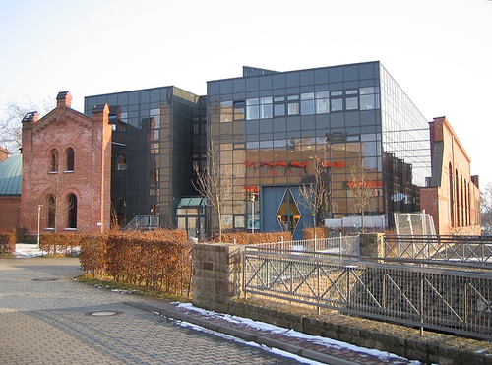
- The CSSG offers language and culture courses in Kassel, Germany, in a unique and intensive immersion program. The CSSG offers the following levels:
- First-year (second-semester) German immersion (A2)
- Second-year German immersion (B1)
- Third-year German immersion (B2)
- Fourth-year German immersion (C1)
- Study-abroad Service Learning (for previous CSSG students only)
- German Community Service Learning (B2 and up)
- Teaching and Learning German (for graduate TAs, B.Ed. students, & in-service teachers).

Eligibility: completion of Western’s German 1030 (for Intermediate courses) & completion of corresponding preceding levels for the advanced courses, plus a Letter of Permission from your Faculty.
Duration: 6.5 weeks (complete one full course of 85 hours and additional activities): May-June
Deadline: January 31 (apply directly to the CSSG, first come first served by course level, important to apply early).

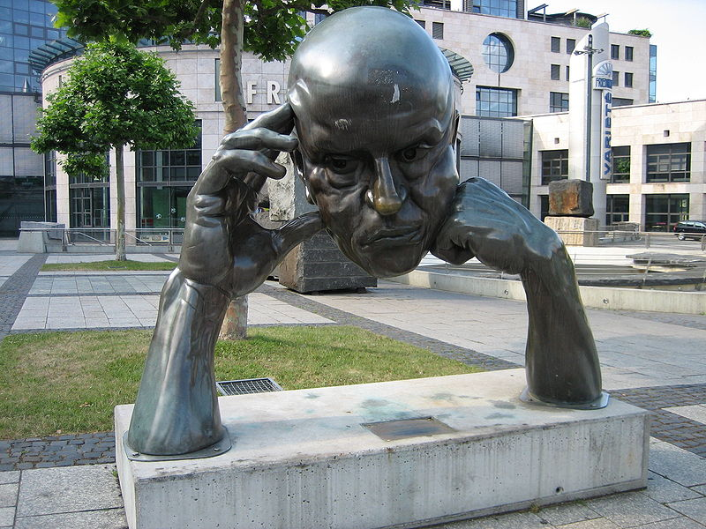
5. STUTTGART UNIVERSITY – SUMMER GERMAN COURSES
Several levels of German language instruction (90 hrs. each): 1.0 Western credit per course. Additional subject courses in 20th Century Architecture, International Business, Cross-Cultural Communication etc. Language courses: mornings. Subject courses: afternoons — with excursions. Accommodation with a host family or in a student dorm.
Eligibility: completion of first year and a US GPA of 2.75 or higher. Letter of Permission from your Faculty required.
Duration: Late May to late June
OWB Link (OBW mediates for Stuttgart as well)
Contact person link at Western International
Cost, Contact etc. in Stuttgart
Deadline: March 15

6. GOETHE-INSTITUT COURSES
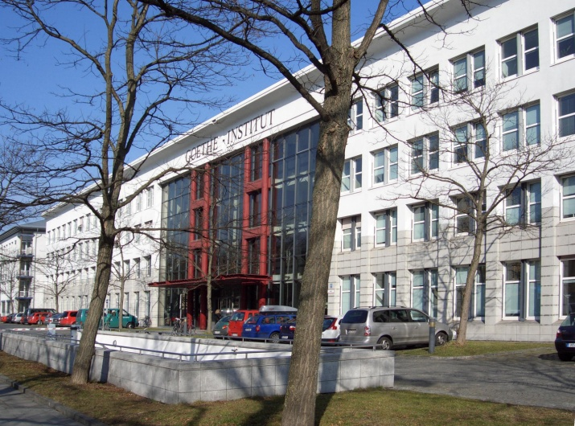
The Goethe-Institut offers an extensive summer program of language courses at locations throughout Germany. These include intensive, super-intensive, and customized courses (e.g. Business German, Language and Culture Program in Weimar). Language certificates for Goethe-Institut examinations are internationally recognized.
Eligibility: must be at least 18 years of age and obtain a Letter of Permission from your Faculty. To receive a grade a separate exam is necessary.
Duration: 2, 4, or 8 weeks.
Cost: transportation cost, course fee, accommodation (private or Goethe-Institut dorms), meals, personal expenses. Prices are listed online.
Main page
Information: Goethe-Institut Toronto: Tel. 416-593-5257; mainoffice@goethetor.org

NB. Many German and Austrian universities and institutes offer summer language and culture courses for foreign students. They include the Universität Heidelberg, the Universität Stuttgart, Duke-Berlin, and Bowling Green-Salzburg programs, the Wiener Internationale Hochschulkurse, and many, many more. Since 1992, the DAAD (Deutscher Akademischer Austauschdienst [German Academic Exchange Service]) has been co-sponsoring several summer institutes in German Studies at universities in the United States and in Germany.
Canadian Year in Freiburg Student Exchange Program
Eligibility: Students must have had 2 years of German/completed the A2 level and obtain a Letter of Permission from your Faculty.
Duration: September-July
Cost: transportation, program fees, accommodation, meals, personal expenses. Prices online.
Award: "Academic Recognition Award" (awards range from $1000 to $1,500).

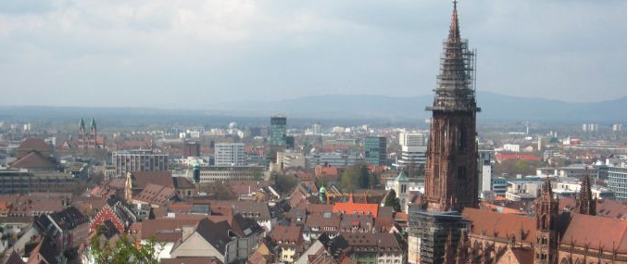

EUROPEAN STUDIES PROGRAM (FU-BEST) - Freie Universität Berlin
Language and subject courses in German for advanced German Studies / German language students or students of European Studies / history / political science.
Eligibility: students past 3d yr. German.
Duration: Semester format (Sept-Dec) (Feb-May)
Contact: fubest@fu-berlin.de

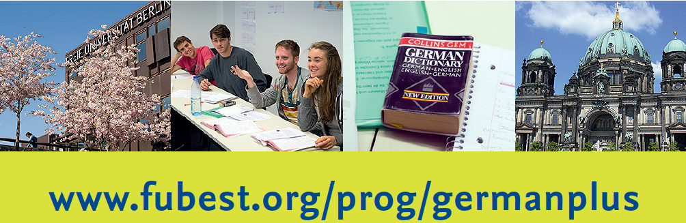
II. Exchange Destinations: All Disciplines

1. ONTARIO/BADEN-WÜRTTEMBERG UNIVERSITY STUDENT EXCHANGE
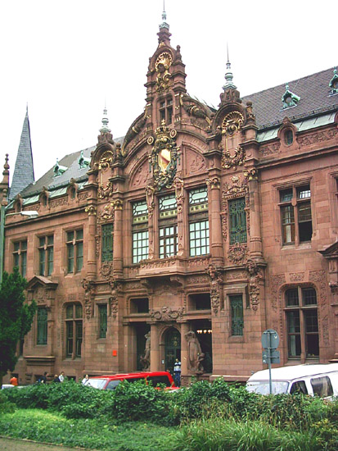
Through an agreement between a consortium of Ontario universities and Baden-Württemberg universities, supported by the governments of Ontario and Baden-Württemberg, up to fifty Ontario students have the opportunity to study for one academic year at a university in Baden-Württemberg.

Eligibility: open to students in almost all fields who, at the time they apply, are pursuing an undergraduate (2nd year or higher) or graduate degree program at UWO and who will be registered in a degree program at UWO during the year abroad. Competence in German appropriate to the field and level of study is required. Students selected will participate in a free, intensive language course and orientation in Germany.
Duration: usually September to July. One semester exchange also possible.
Cost: UWO tuition, travel, plus normal living expenses. Students may also apply OSAP, OGS, or a UWO scholarship to their year in Baden-Württemberg.
Scholarship: http://www.uwo.ca/international/learning/go_abroad/funding.html
Deadline: Application must be made to Western International; UWO deadline: January 15, 2023.
Contact person link at Western
URL: http://obw.ouinternational.ca/ (full information, downloadable application forms)
http://www.uwo.ca/international/learning/go_abroad/study/exchange/index.html

II. Exchange Destinations: Subject-Specific Exchanges

2. UNIVERSITY OF MAGDEBURG
The University of Magdeburg offers courses focused on engineering, natural sciences and medicine. All courses are taught in English. It is possible to apply to live on campus

Eligibility: undergraduate students in the Department of Economics or the Bachelor of Management and Organizational Studies program. A CV, statement of purpose, transcript and online application form is required for admission.
Duration: one semester or year long
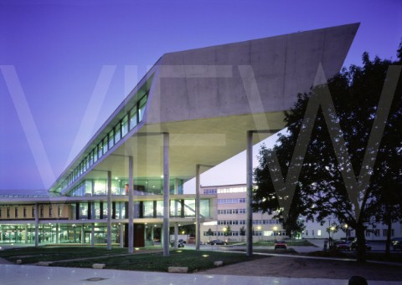

Cost: UWO tuition, as well as an administrative fee of approximately $90 that covers public transportation.
Deadline: January 16, 2024.
Contact person link at Western

- EUROPEAN BUSINESS SCHOOL
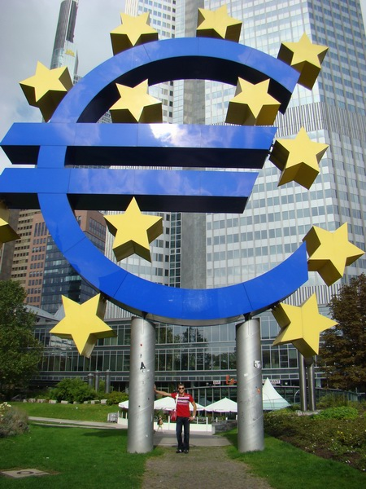
80% of courses are taught in English, and two weeks prior to the start of each semester, EBS offers intensive German lessons for exchange students, free of charge. On-campus accommodations are very limited but the university helps with finding international students furnished accommodation.

Eligibility: undergraduate students in Management and Organizational Studies and students with a specialization in Commercial Aviation Management
Duration: 1 term (Fall/Spring), or 1 full year
*Year long Exchanges are encouraged
Cost: UWO tuition fees, plus travel and living expenses.

Funding: https://www.ebs.edu/en/scholarships-financing
Deadline: January 16, 2024.
Contact person link at Western
URL: http://www.uwo.ca/international/learning/go_abroad/study/exchange/

- THE GERMAN SPORT UNIVERSITY, COLOGNE
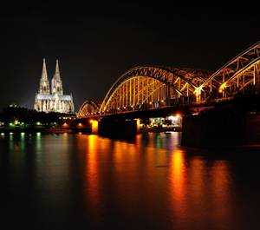
The German Sport University, Cologne (Deutsche Sporthochschule Koln) is Germany's largest and most prestigious center of teaching and research in physical education and sport sciences. Through its 20 scientific departments, the university covers a wide range of sport-science teaching and research. More than 30 sports are taught in theory and practice in its modern facilities. Courses are taught in both English and German.
Eligibility: only Graduate and undergraduate Kinesiology students may apply
Duration: one semester or a full year

Cost: UWO tuition fees, plus travel and living expenses
Contact person link at Western

