AI Lay Summary Instructions – MSK Innovation Factory

- Create a lay summary via the tool designed by James Shelley: https://forms.office.com/r/mfKUq4CdTe
Upload a manuscript in the ‘Upload File’ box. Select submit. Provide your email address. The AI lay summary will be sent to your email.
- Transfer/Format according to the ‘Lay Summary Template’ ( MacDermid template on page 2).
- Create an AI generated image via Gemini for the lay summary:
https://gemini.google.com/app?utm_source=google&utm_medium=cpc&utm_campaign=2024enCA_gemfeb&gad_source=1&gbraid=0AAAAApk5BhmBQPmoFM3PYQsrM7Pms8BVn&gclid=CjwKCAjw9p24BhB_EiwA8ID5Blbj63JtkGl_ATSBHPaXJ0lBPBxtZ18jy4F01c3_cJmjehvqG4y7GhoCrwUQAvD_BwE&gclsrc=aw.
Make sure to specify that you want an ‘AI Generated Image’ in the prompt field.
- Conduct a Scientific Review of the lay summary for accuracy and make any necessary revisions (by authors or experts in the field).

- Conduct a target audience review (by People with Lived Experience and relevant decision-makers)

- Make any final edits to the lay summary.

- Disseminate.

Insert research article title
We wanted to know: write the research question in format simple direct fashion.
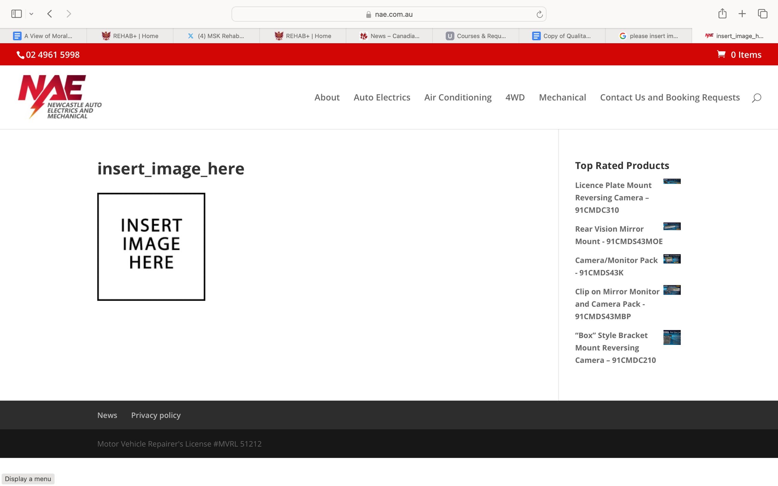

What is the problem?
Write a few sentences about the background that is important to this work. What is the problem? What is the gap? How will the information be used?

Insert your own picture/graphic as per above

Remember these will potentially be printed off as PDFs by interested knowledge users (limit to 1 page)

How did the team study the problem?
This is a lay version of your methods. It may include a lay description of the overall research approach. It should identify who participated in the research and what research measurements or procedures were used in a way that is not technical. What analyses were used to address the question?

What did the team find?
A lay version of the results should state the main findings in a non-technical way, and any overall conclusion.

How can this research be used?
This should briefly state how the results could be applied in practice.

Cautions
Individual research studies have limitations, and any one study may not provide a definitive answer on a question to fully address the question for the knowledge user. Point out key limitations in the study such as who the results might not apply to (generalizability) or important issues that were not measured. You may also need to make a statement about whether these findings are ready to be more broadly implemented.
Reference: give the actual citations so that your paper can be tracked down for those who want the full scientific version
Funding Sources: identify funding source if applicable

