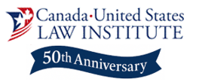

You are Cordially Invited

50th Anniversary Conference of
The Canada-United States Law Institute
The Future of Canada-United States Relations
Monday, May 11th, 2026 – 8:30 am – 5 pm
Johns Hopkins University Bloomberg Center, Washington DC
555 Pennsylvania Ave NW, Washington, DC 20001

The Canada – United States relationship has come under stress recently and there are numerous opinions and perspectives on where it is headed. This very important relationship, precious to both countries, needs to be examined and understood and its value needs to be preserved. As a result, the Canada – United States Law Institute, which is celebrating 50 years of insight and analysis of the policy and legal issues facing Canada and the United States, will dedicate its annual conference to “The Future of Canada-United States Relations.”

The all-day conference will include important keynote presentations and four panels moderated by recognized current and former ambassadors, government officials, and leaders as well as experts in their fields as panelists. Highlighted speakers, presenters and panelists include:

- Mark D. Wiseman, Ambassador of Canada to the United States
- Hon. David Cohen, Former United States Ambassador to Canada
- Hon. David Jacobson, Former United States Ambassador to Canada
- Hon. James Blanchard, Former United States Ambassador to Canada and Governor of Michigan
- Colin Bird, Consul General of Canada in Detroit, Michigan
- Hon. Peter MacKay, Canada’s Former Minister of Justice, Foreign Affairs, and National Defence
- Charlie Dent, Former United States Representative from Pennsylvania
- Donald Bacon, United States Representative from Nebraska
- Fred Upton, Former United States Representative from Michigan
- Stephen DeBoer, Former Canadian Representative to the World Trade Organization
- Thomas Lawson, Retired Canadian Air Force General and Deputy Commander of NORAD
- Martha Hall Findlay, Professor of Law, The School of Public Policy, University of Calgary, Former Member of the Canadian Parliament, and Former Chief Sustainability Officer and Chief Climate Officer, Suncor Energy
- Christopher Sands, Director, Senior Research Professor, Johns Hopkins University
- Beth Burke, CEO, Canadian American Business Council
- Ian Sheldon, Andersons Chair in Agricultural Marketing, Trade and Policy, Ohio State University
- Diane Francis, Editor-at-Large for National Post
- Josh Rogin, Lead Global Security Analyst for Washington Post
- Todd Spangler, Washington Correspondent for Detroit Free Press

Click Here to Register Today!
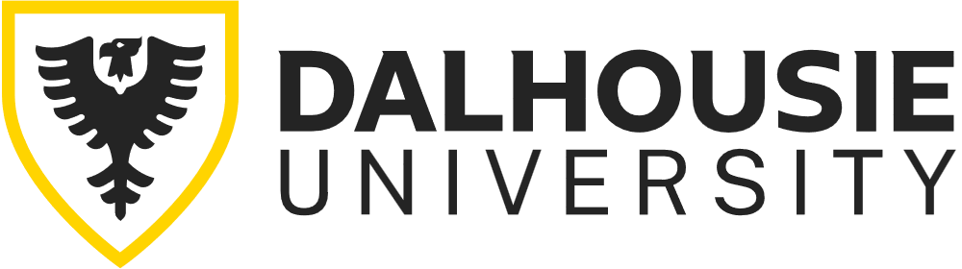

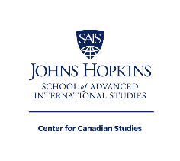
The Canada – United States Law Institute is a partnership of Case Western Reserve University School of Law and the University of Western Ontario, and this conference is presented with the support and cooperation of Johns Hopkins University School of Advanced International Studies as well as the Canadian Studies Center at Michigan State University and Dalhousie University.

