A Brief Introduction

1959: Born In Athens, Ohio
1981: Bachelor of Arts in Architecture, Yale College
1986: Master of Architecture, Yale University

I feel I exist on boundaries. Somewhere between science and art, art and architecture, public and private, east and west. I am always trying to find balance between these opposing forces, finding the place where opposites meet. - M. Lin

Throughout Maya Lin's body of work, one can see a profound respect and love for the natural environment. Her interest in nature, art and architecture has led to works that attempt to merge natural forms into architectural spaces and art installations. She has a particular interest in natural topographies and geologic phenomena, finding inspiration from rock formations, ice floes, water patterns, solar eclipses, and aerial views of the earth. Influenced by the Earth Artists of the sixties and seventies, Lin takes the theme of the landscape and gives it a contemporary twist. Utilizing modern technology and science, she draws on the rational and technological way they view the world and translates that into sculptural forms. She has created a systematized way to view natural phenomena, and this was the inspiration for her recent exhibition Systematic Landscapes (2006-2009).

The focus of Lin’s work is how humans respond to the environment. By taking natural forms and presenting them in new locations, she offers the viewer new ways of looking at the world around them. Her installations require the viewer’s complete attention to the sensory experience surrounding the art, whether it is works like 11 Minute Line (2004), which requires the viewer to walk around the earthwork, or the Storm King Wavefield (2009) which gives the viewer an experience is similar to that of being at sea.

Confluence Project: Sandy River Delta
A confluence is the merging of two bodies of water. The Confluence Project is defined by the merging of art, architecture, Native American culture and a deteriorating environment. Its aim is to transform and reclaim seven points along the Columbia River Basin where the river meets other waterways.
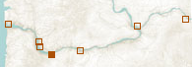
The Sandy River Delta is where the Sandy River and Columbia River meet in Troutdale, Oregon. Due to the extensive damming, the waterline has receded and the lands are now overgrown with weeds. The Confluence Project aims to restore and reflood the area with the help of the National Forest Service.

At this site, Lin designed an elliptical bird blind. The bird blind acts as a camouflage, with its occupants concealed by vertical slats, each one listing a species, with their modern name and their status today: thriving, threatened, endangered, or extinct. These slats pay tribute to the 134 species that Lewis and Clark recorded on their expedition to the Pacific. The work is a memorial to those species lost, serving as a reminder of the human impact on the land. As Lin states, ”The art is about helping people get in touch with the land. Maybe if you realize what’s gone, you’ll think more about the future. “
The Bird Blind is constructed of black locust, which is a sustainably harvested and weather resistant wood. This species was introduced by early settlers and is invasive to others trees in the Northwest. By creating the bird blind of this wood, Lin is taking a harmful material and using it as a means of seeing the land’s beauty as an unobtrusive observer.
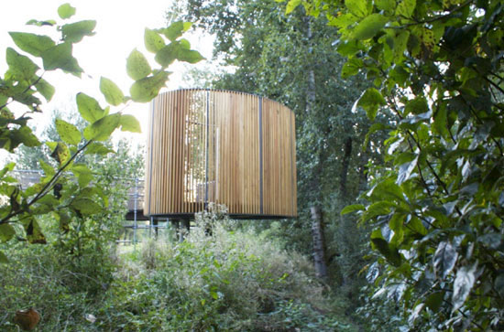
Pin River: La Grande

Lin’s Systematic Landscapes Exhibition at the Henry Art Gallery featured a work titled Pin River- Columbia (2006). It was composed of tens of thousands of steel pins. They were pushed directly into the wall to create a topographic image of the Columbia River. Within this work, Lin has created a subtle environmental message by exaggerating the number of pins at the eleven dam sites along the river. One needs to keep in mind while viewing this work that the Columbia River is the largest hydroelectric power-producing river in North America. The installation of multiple dams along the river has dramatically altered its landscape and has been highly destructive to the surrounding ecosystems.
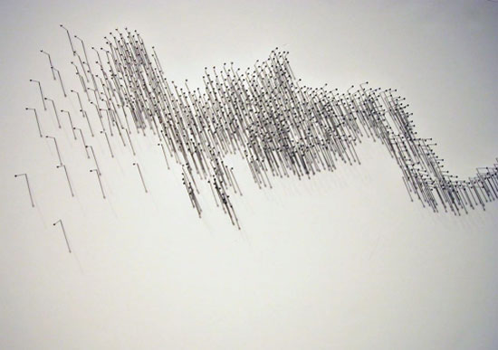
Pin River- Columbia Systematic Landscapes Exhibition, 2006

In Pin River-La Grande, we will be exploring Lin’s interest in natural topographies and geological phenomena. There will be a large-scale re-creation of the topographic outline of the La Grand Rivière in Quebec. This outline will be composed of 2,000 small nails. The river will be constructed in its current state, which is composed of four large reservoirs of flooded water created by the large-scale hydroelectric dams and river diversions. In the likeness of Lin we will also create exaggerated swelling of nails around the eight generating stations. By using an unnatural substance to create the river, we are also speaking towards the contaminants of human intervention on the land by creating dams. The creation of hydroelectric reservoirs has resulted in a serious environmental problem for the Cree people. As large amounts of vegetations are submerged it water they release high levels of methylmercury contaminants. These contaminants then enter the aquatic food chain and infect the fish that are the main food supple for the Cree. Our Project aims to be pleasing to the eye but also direct some attention to the environmental concerns we face in our own country.

Selected Works and Exhibitions

1985: Aligning Reeds, New Haven, Connecticut
1991: Topo, Charlotte Sports Coliseum, North Carolina
1993: Groundswell, Wexner Center for the Arts, Columbus, Ohio
1995: The Wave Field, FXB Aerospace Building, University of Michigan, Ann Arbor
1996: Sounding Stones, Federal Courthouse, New York City
1998: Topologies, Cleveland Center for Contemporary Art, Ohio
1999: Maya Lin: Recent Work, Gagosian Gallery, Los Angeles
2000: Time Table, Stanford University, California
2001: Ecliptic, Frey Foundation, Grand Rapids, Michigan
2002: the character of a hill, under glass, American Express Financial Advisors Client Service Center, Minneapolis
2004: Eleven Minute Line, Wanås, Sweden
2005: Garden of Perception, School of Fine Arts, University of California
2006: Systematic Landscapes, Henry Art Gallery, University of Washington, Seattle
2007: Above and Below, Indianapolis Museum of Art, Indianapolis
2008: Where the Land Meets the Sea, California Academy of Sciences, San Francisco
2009- What is Missing? California Academy of Sciences, San Francisco
Work in Progress: Confluence Project: seven-part installation along the Columbia River basin

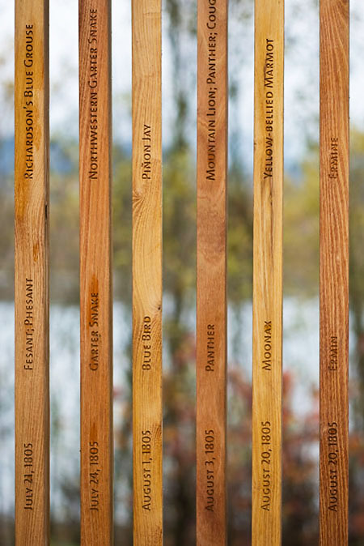
Confluence Project: Sandy River Delta, Bird Blind Wooden Slats

BY:
Sarah Szak & Brittany Medeiros

Maya
Lin

